**User manual – FE595 Final Project**

1. Open Browser and type <http://localhost:5000/> following screen will be opened

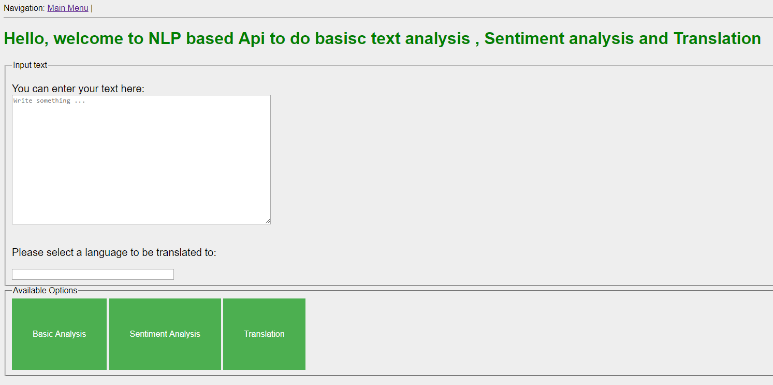

1. Input a test (word / sentence or paragraph) to be analyzed and click on one of the buttons below
2. If you type “This nlp based api is too good!” and click on basic analysis following results will be shown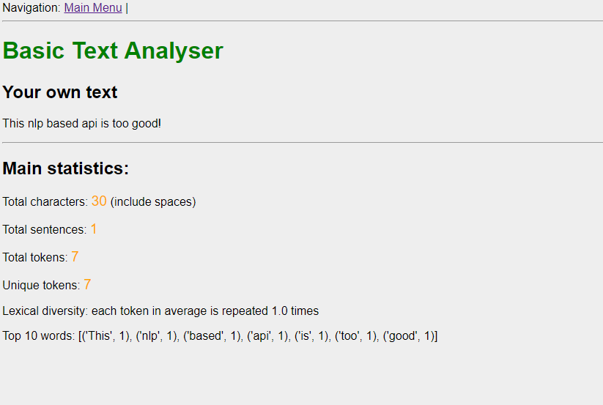

If you choose to do sentiment analysis following results will be shown

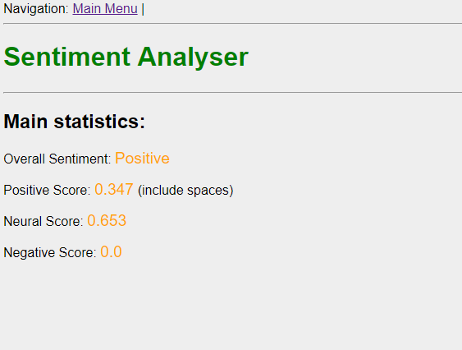

1. If you want to translate then after text input select a language to which the input text need to be translated.
2. Ex : if input text is Good morning and language selected is Spanish following results wil be show,

